Sound and GUI Plan

1. Practice with images and sound
2. Build JavaHangman

# Movie Monster Setup

Download the moviemonster.zip file. Extract it somewhere

1. Create a new project, remove main and add a JFrame
2. Create a new JLabel and three buttons
   1. JLabel = imageLabel, resize as a tall rectangle
   2. Button1 = alienButton
   3. Button2 = halloweenButton
   4. Button3 = friday13thButton
3. Drag the images and sound files to the package
4. Drag the sounds to the package

# Set up the code

## Create these variables

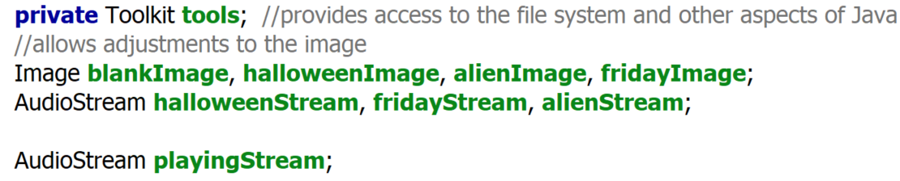

If necessary, import these

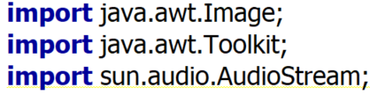

# Create the form icon

In the constructor, add these after initComponents()

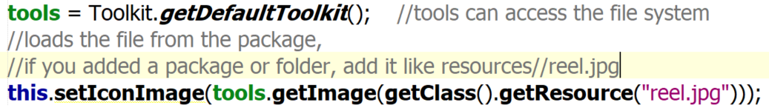

Run, the icon should be in the upper left

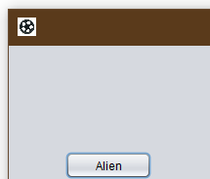

# Code Halloween Button Image

1. Images are different sizes, and we need them to fit in the JLabel
2. Double click the button

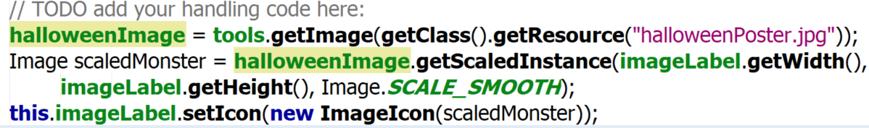

# Code Halloween Button Sound

In the button handler

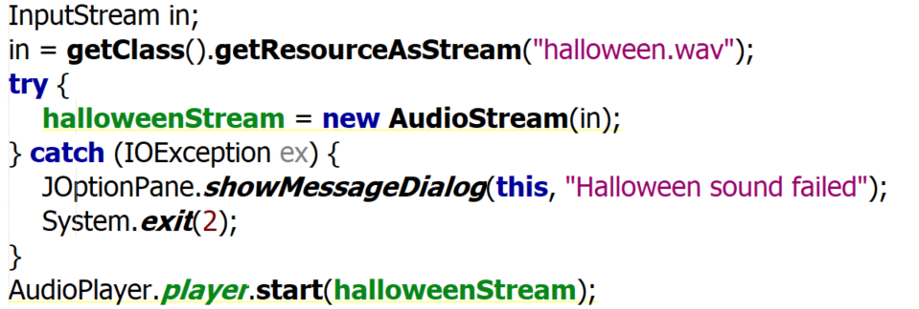

# Problems

1. Loading images in buttons is slow
2. Loading sounds is really slow
3. Just playing the sound will cause problems (Spongebob problem)
4. Repeating for each button is a copy/paste – very bad. Will use methods instead

# Load the assets

1. Create a method named loadAssets() with your variables
2. Load the images  
   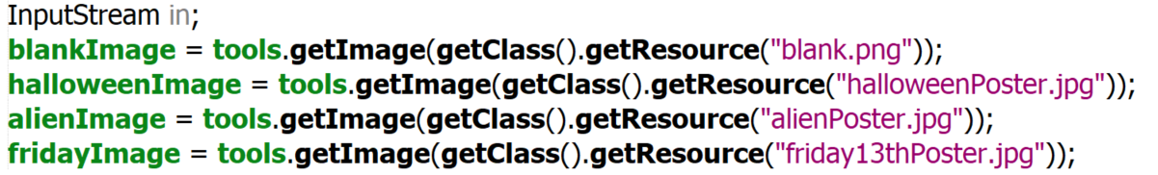
3. Load each sound (repeat for each sound)  
   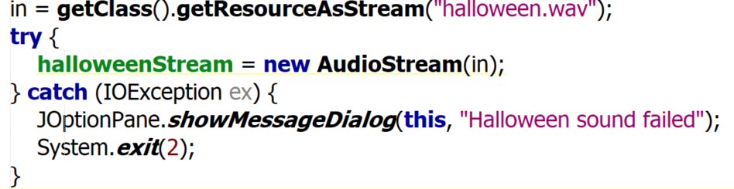
4. Call loadAssets in constructor  
   
5. Make sure it runs

# Create method for show image

1. Create this method 
   1. Will accept the image to show as a parameter
2. Move the image code from Halloween to here
3. Delete the first line (halloweenImage = )
4. Change the highlighted line  
   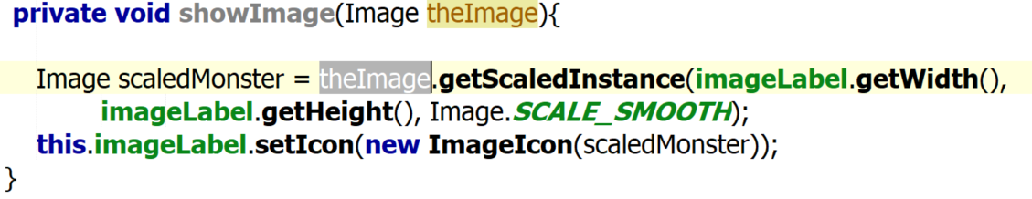
5. Call in the button  
   
6. Make sure it runs and still works

# Create method for play sound

1. Create this method 
2. Add this code to play the sound  
   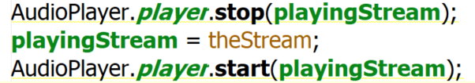
3. Remove all sound lines from Halloween button
4. Call this method  
   
5. Halloween now looks like this  
   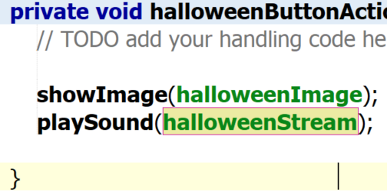
6. Run and ensure it works

# Get the other buttons to work

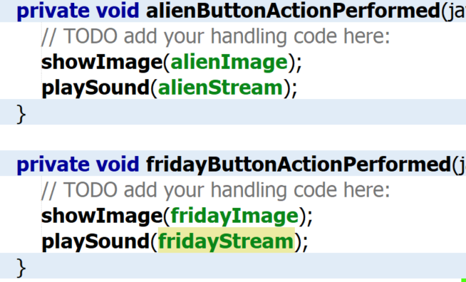

1. If desired, set a startup image in constructor
2. showImage(blankImage);